Nalongsone Danddank Student ID : 14958950 StarID: jf3893pd

Email: [nalongsone.danddank@my.metrostate.edu](mailto:nalongsone.danddank@my.metrostate.edu)\

**ICS 432 - 01 — Distributed and Cloud Computing Fall 2021**

**Lab #10 :** Serverless Compute: AWS Lambda and GCP Cloud Functions

Exercise 1: AWS Lambda

**Part 1: Create a Lambda function with default function code**

**Lab report screen-shot #1:**

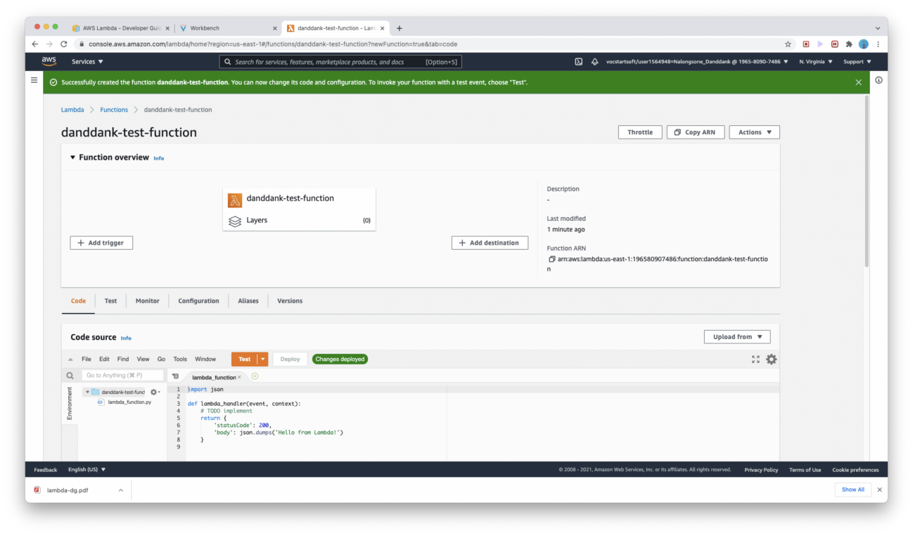

**Lab report screen-shot #2:**

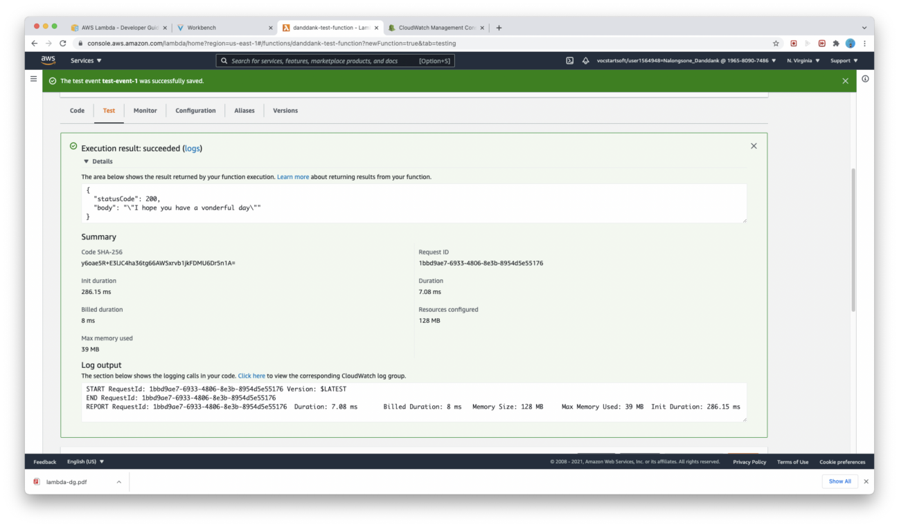

**Lab report screen-shot #3:**

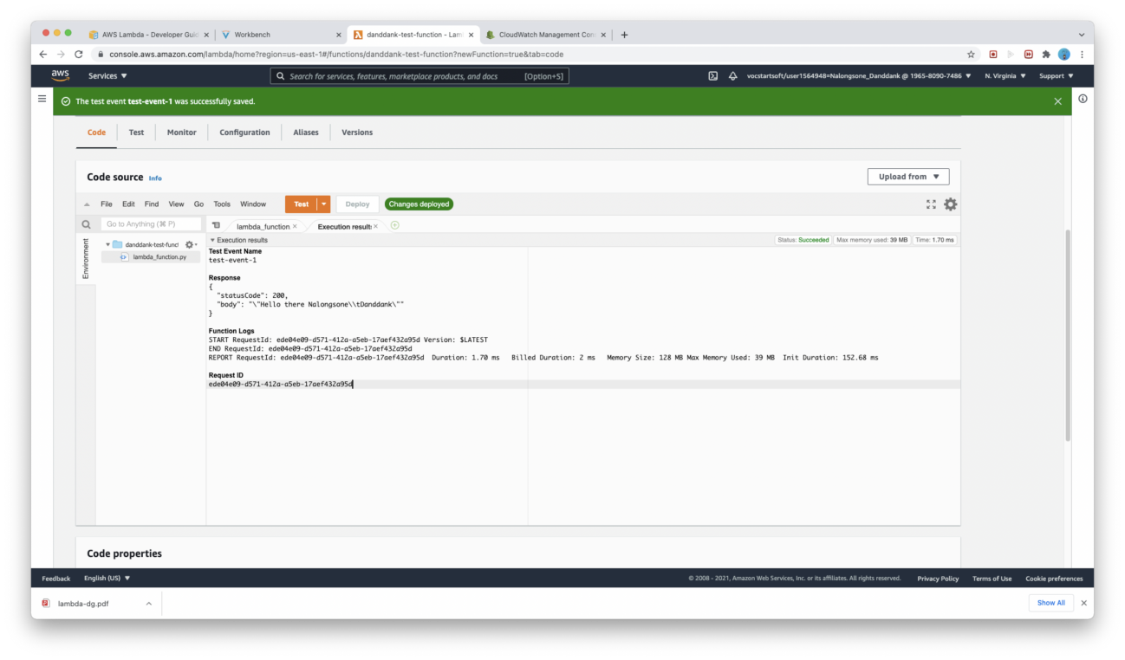

**Lab report screen-shot #4:**

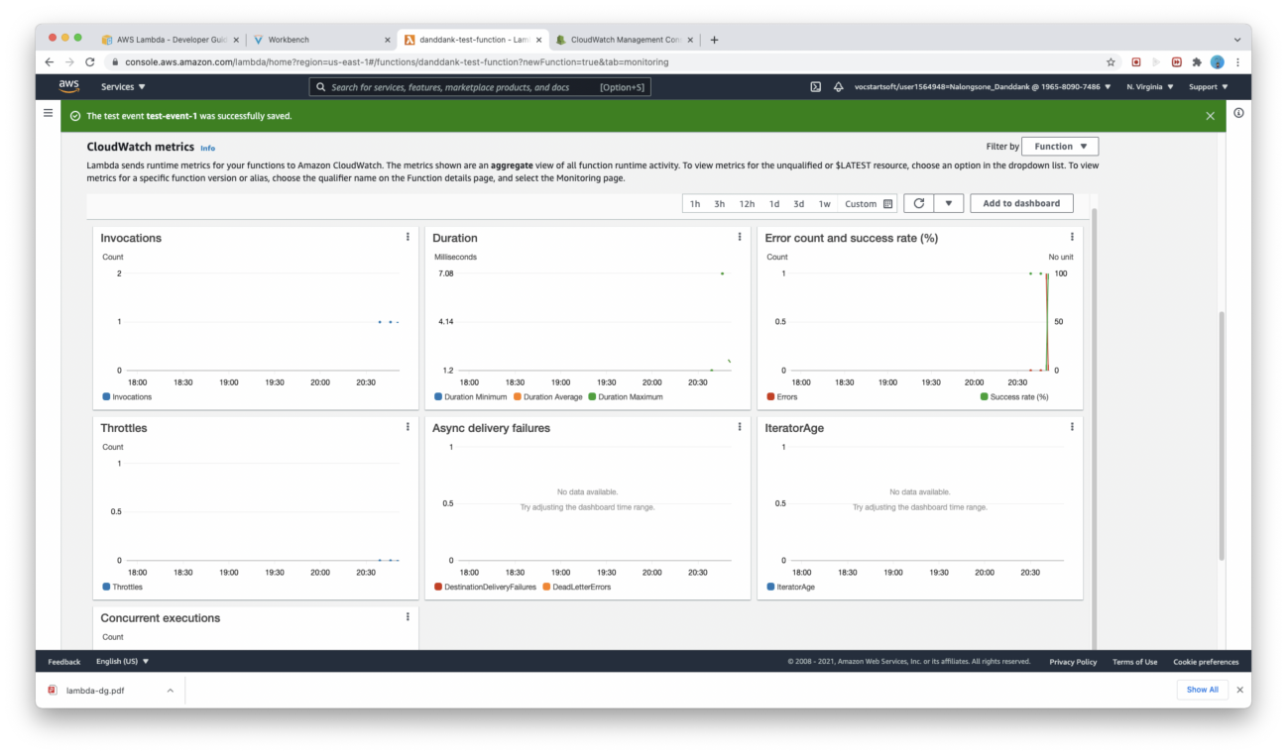

**Part 2: Create an S3-triggered Lambda function**

**Lab report screen-shot #5:**

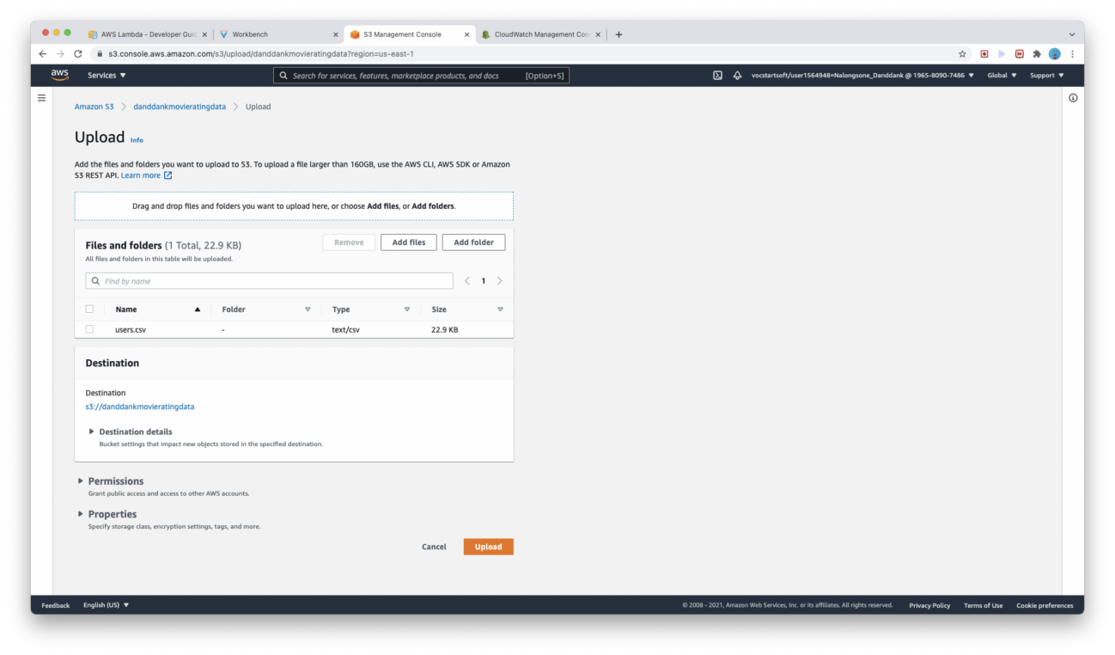

**Lab report screen-shot #6:**

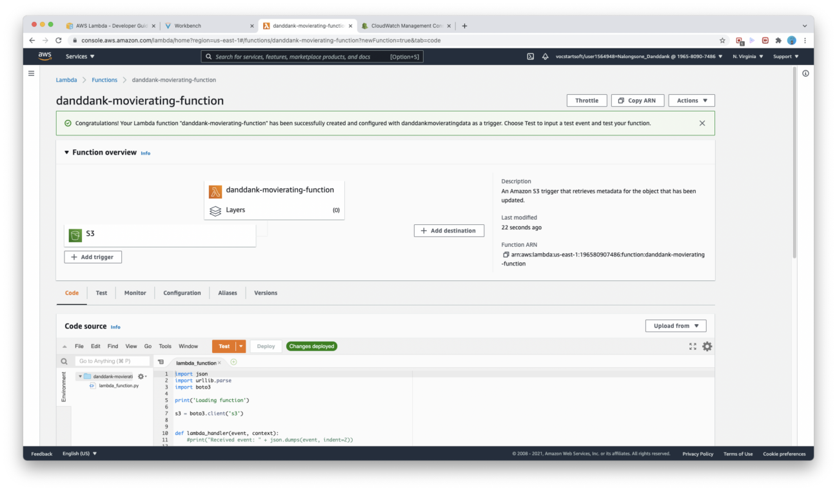

**Lab report screen-shot #7:**

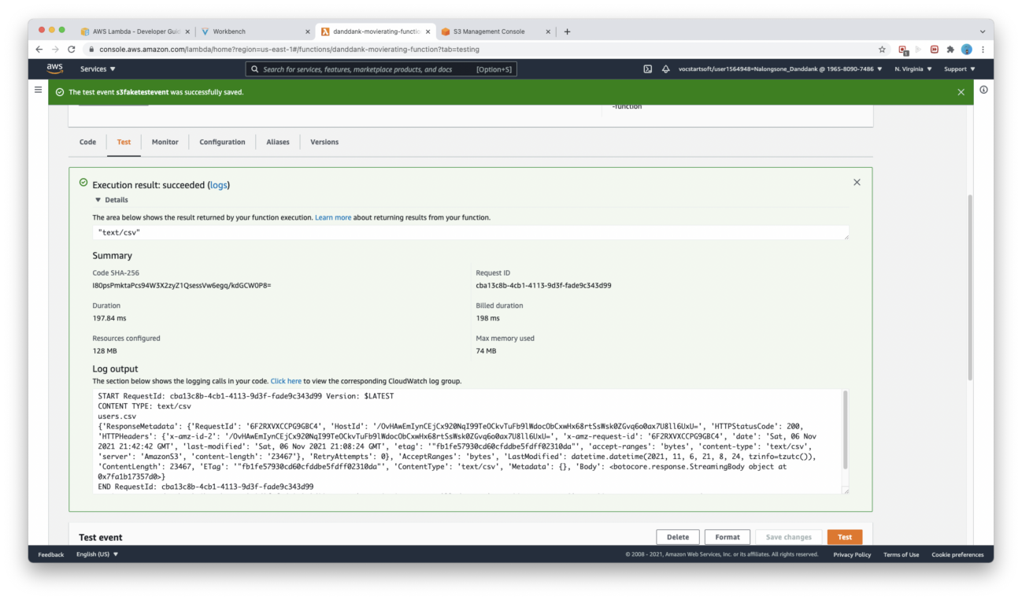

**Lab report screen-shot #8:**

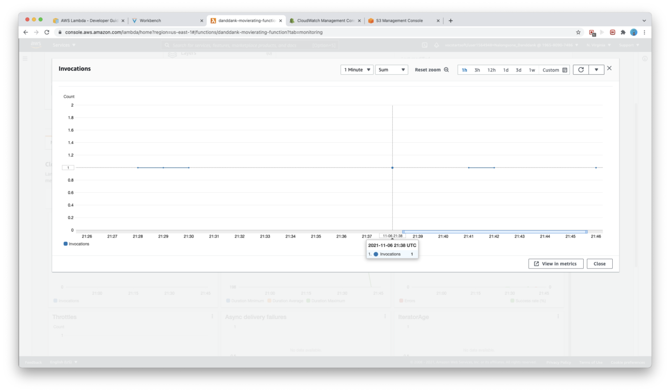

**Lab report screen-shot #9:**

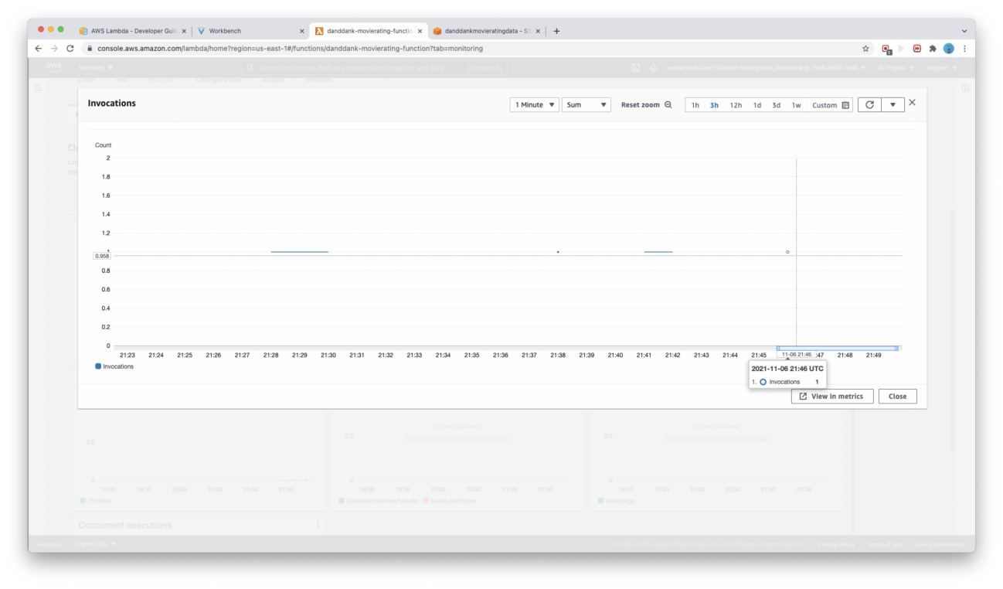

**Lab report screen-shot #10:**

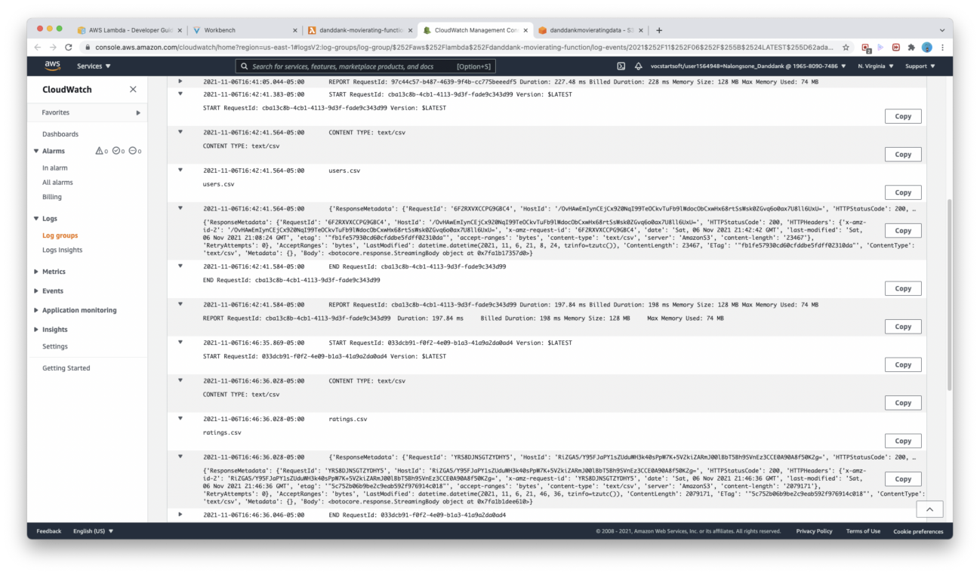

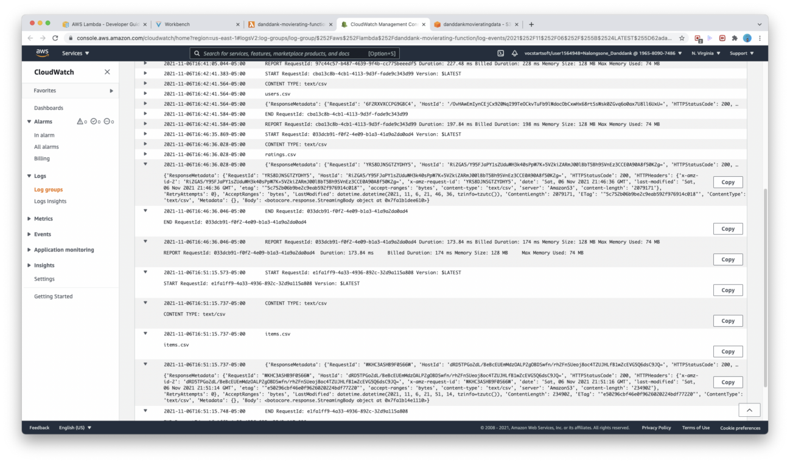

**Lab report screen-shot #11:**

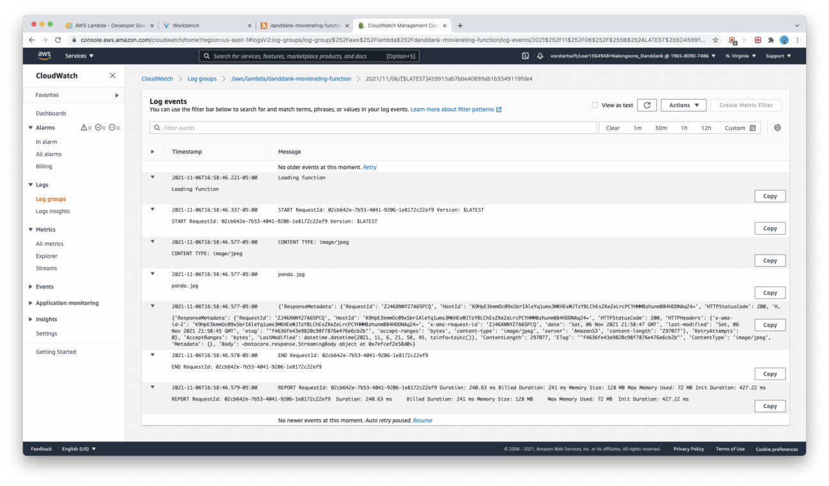

**Lab report screen-shot #12:**

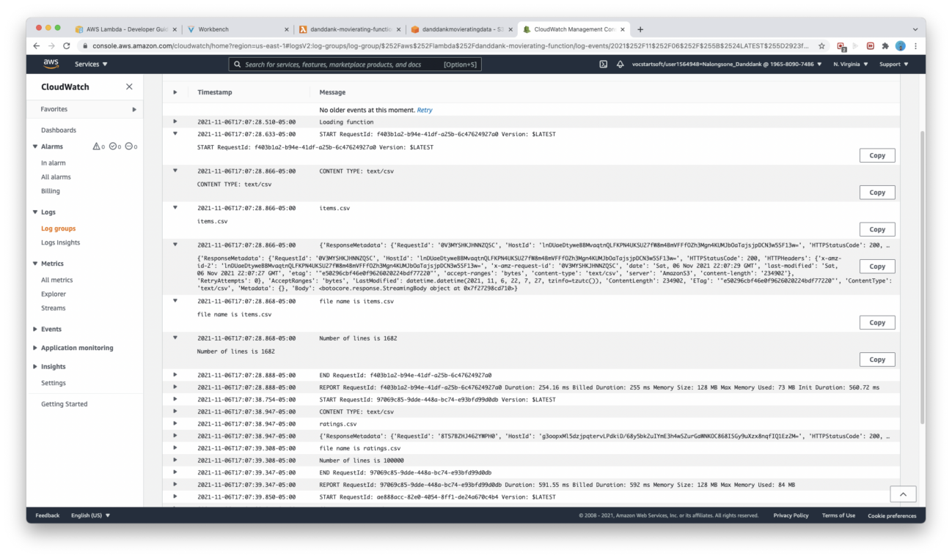

**Lab report screen-shot #13:**

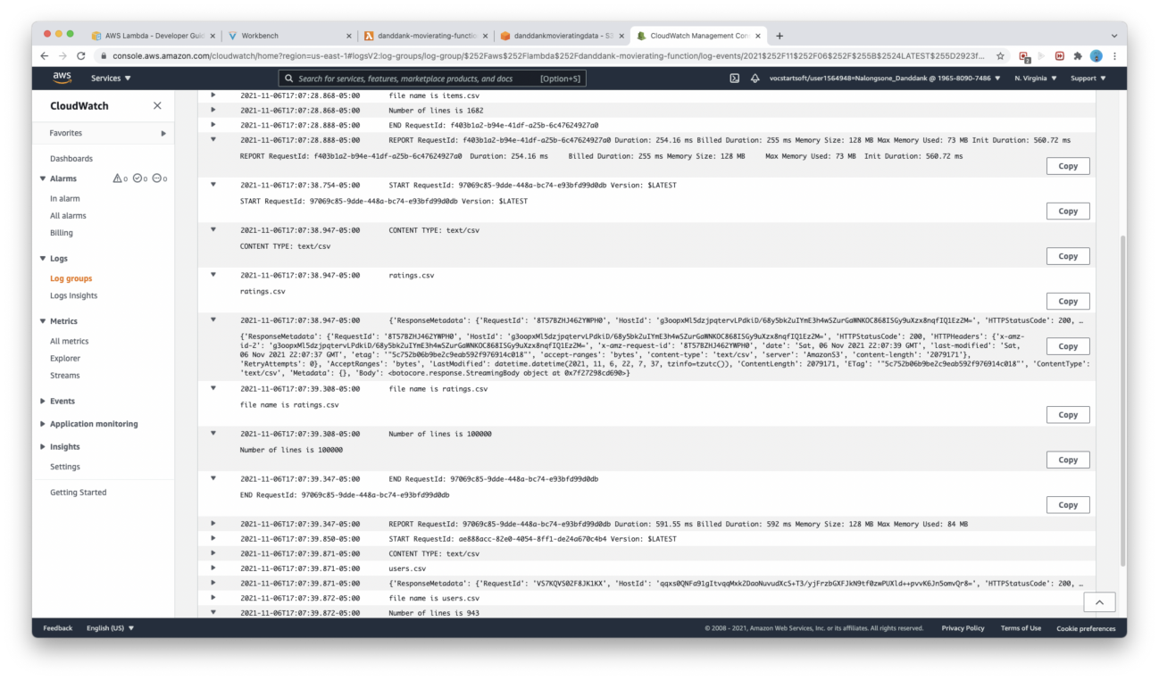

**Lab report screen-shot #14:**

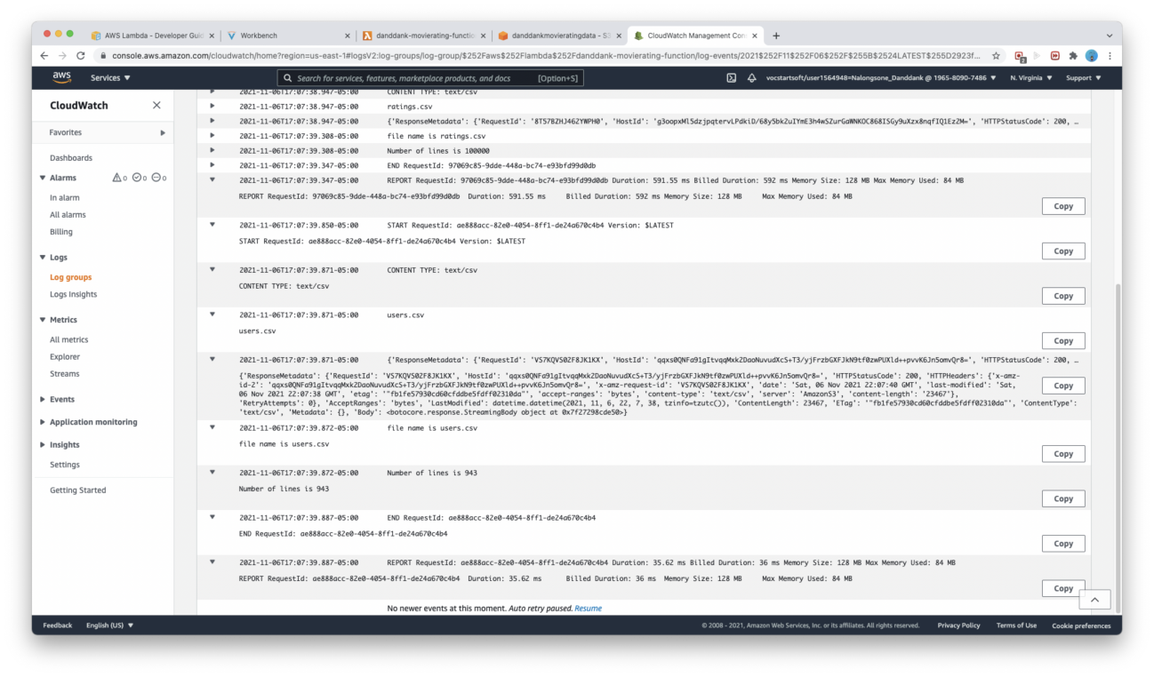

**Exercise 2: Google Cloud Functions**

**Part 1: Creating a storage-triggered function**

**Lab report screen-shot #15:**

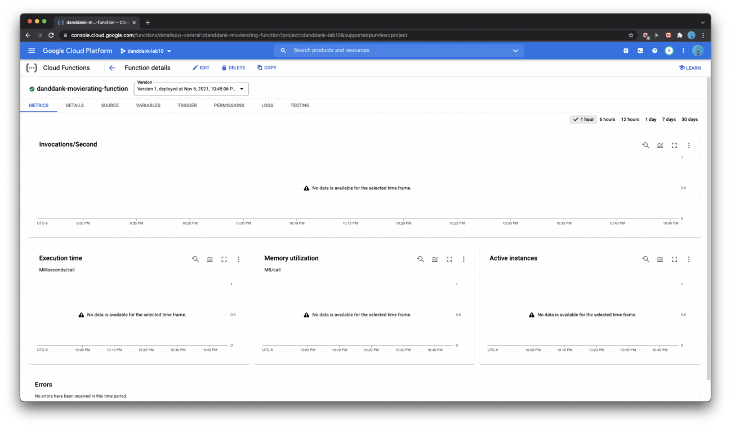

**Lab report screen-shot #16:**

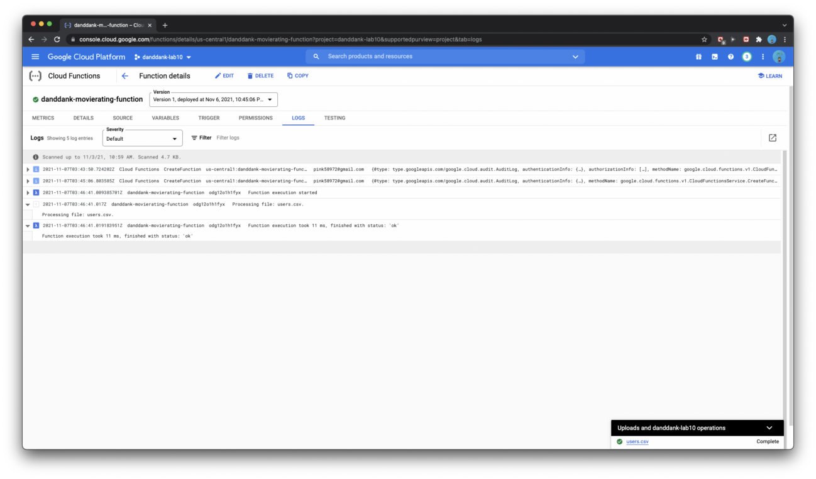

**Lab report screen-shot #17:**

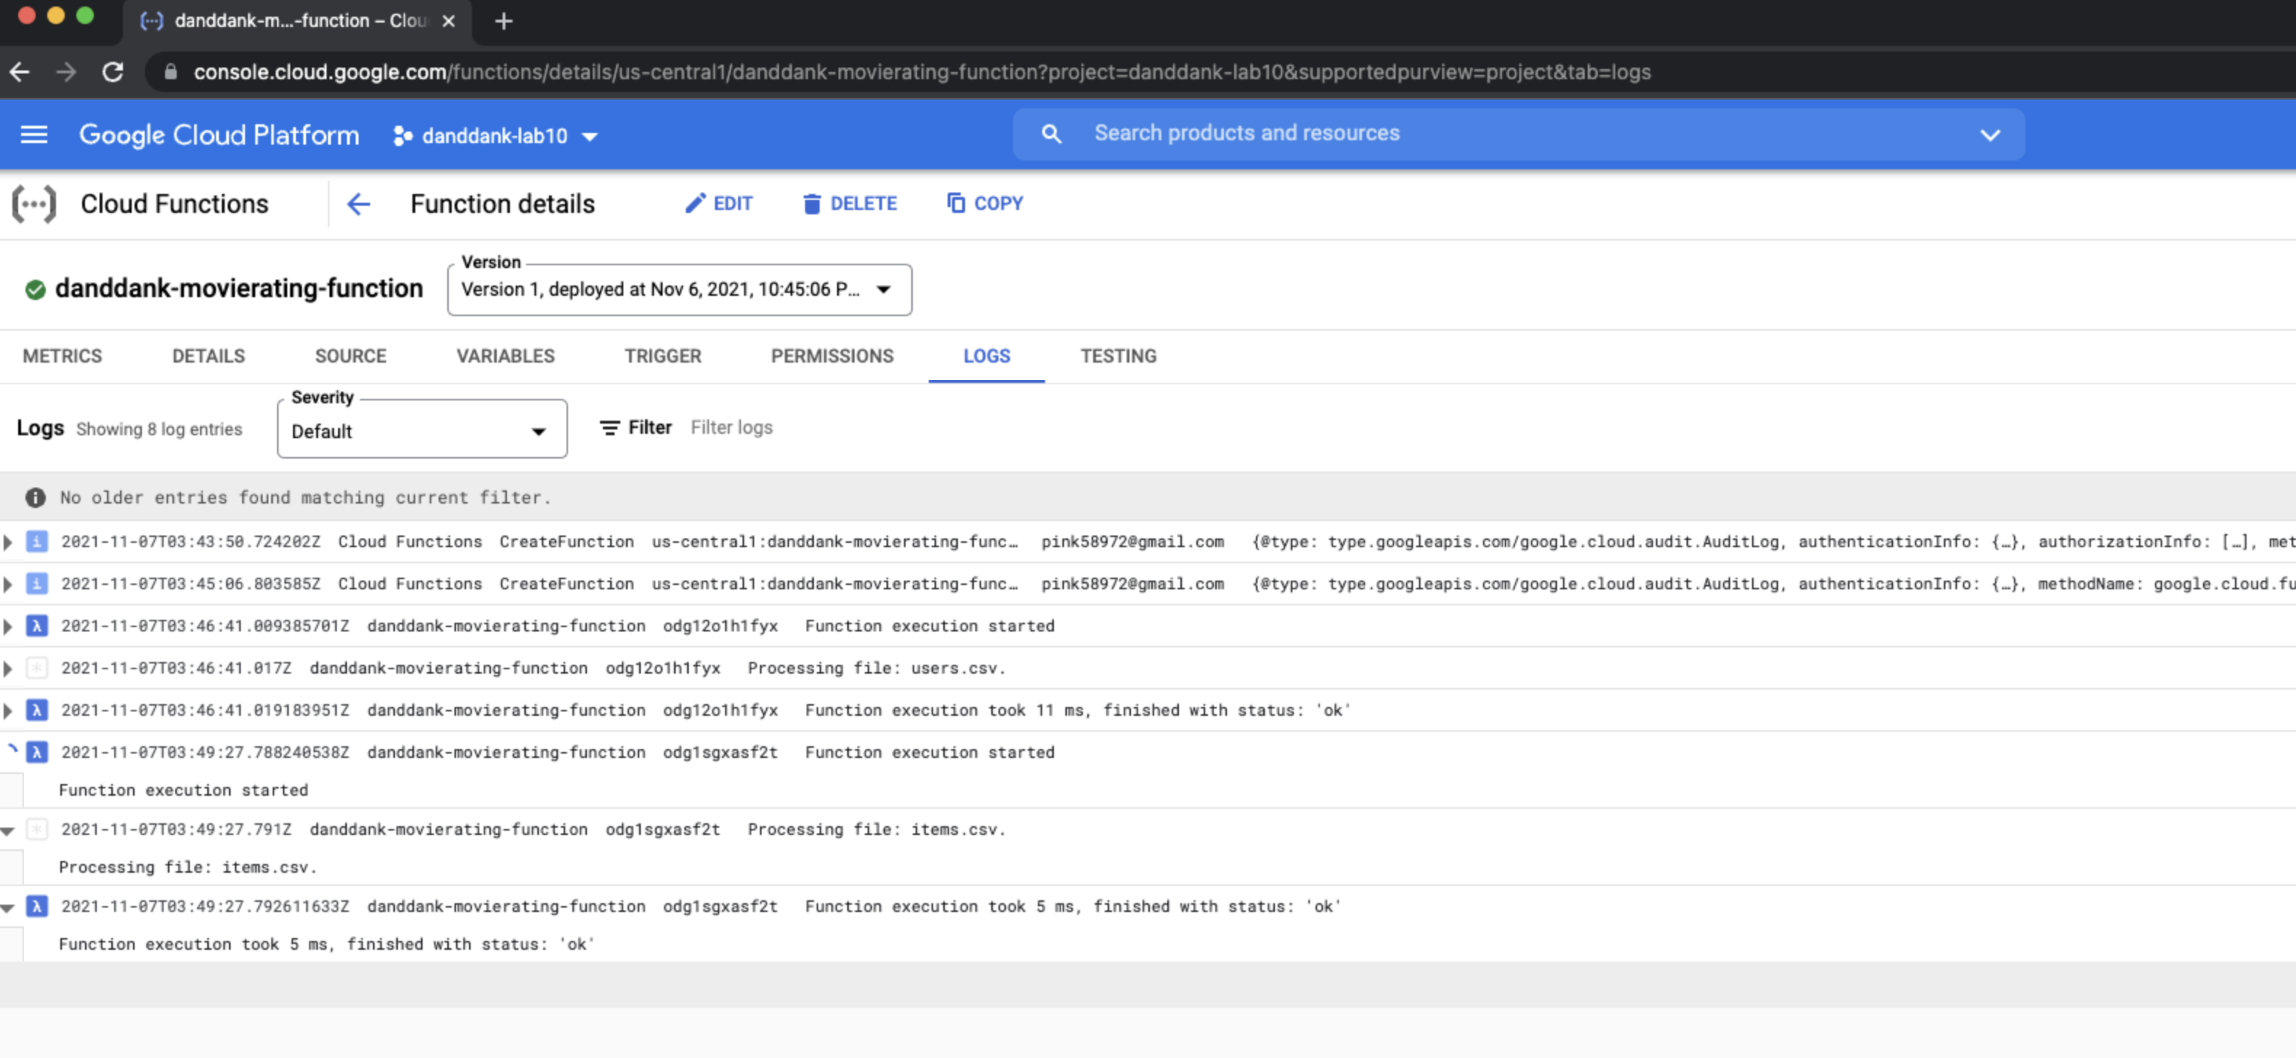

**Lab report screen-shot #18:**

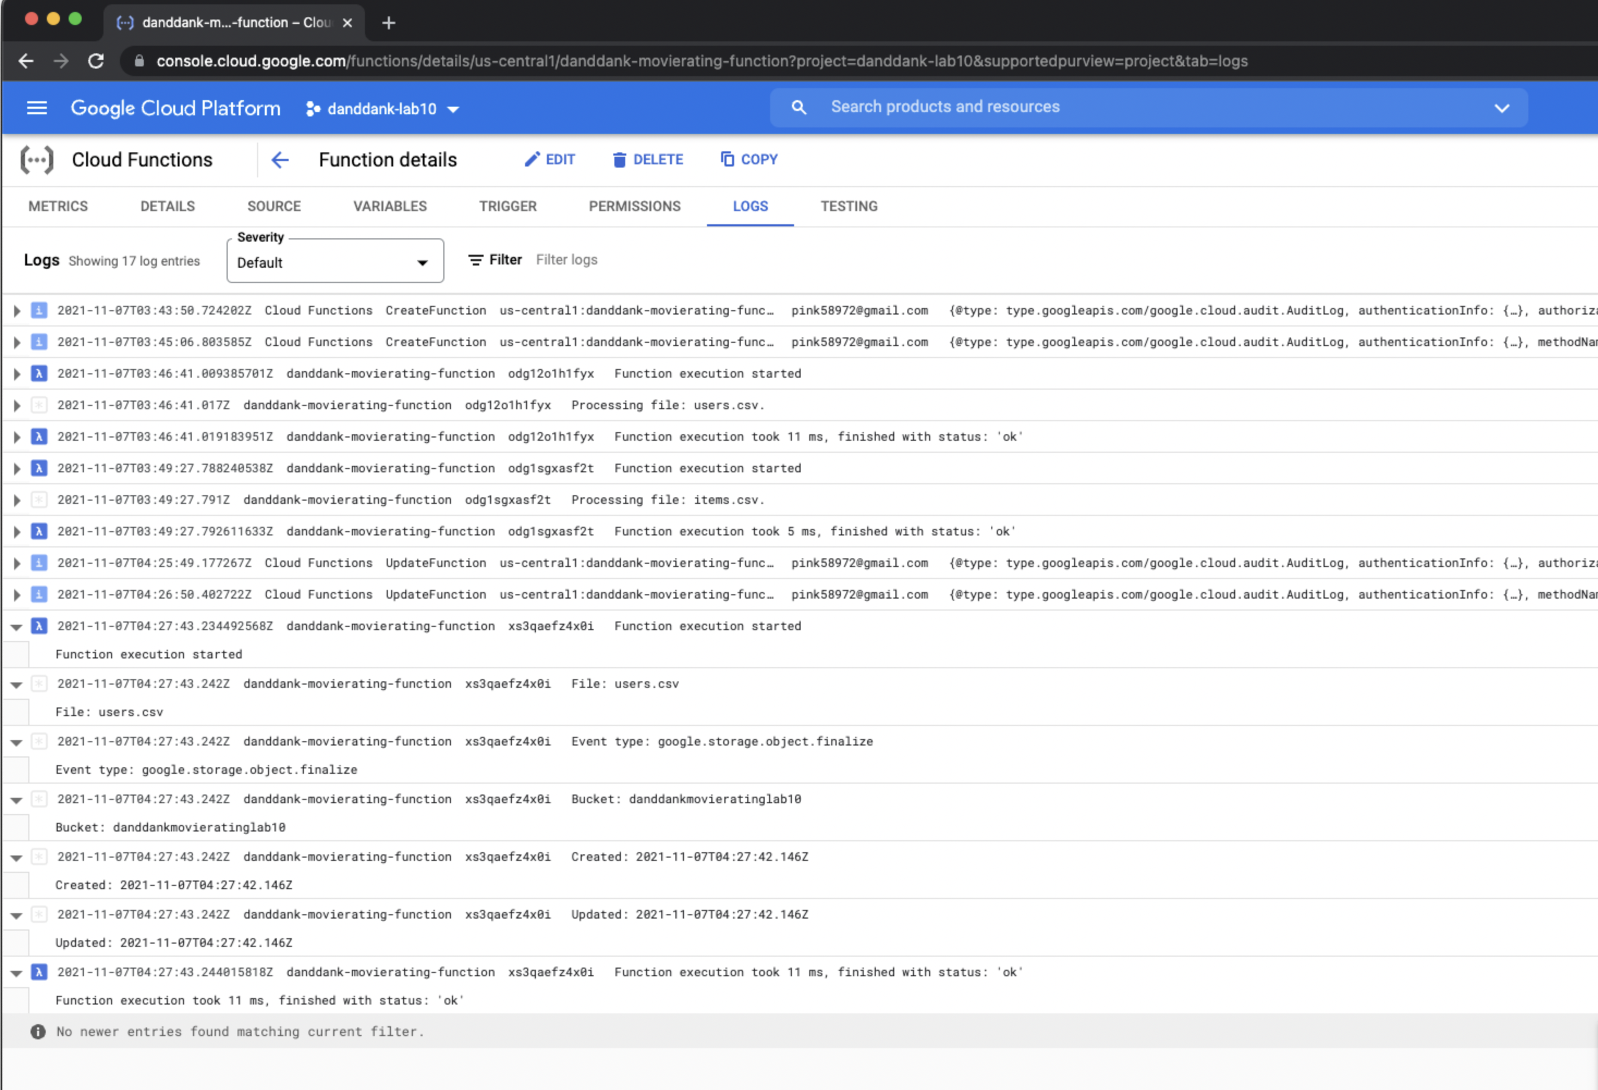

**Lab report screen-shot #19:**

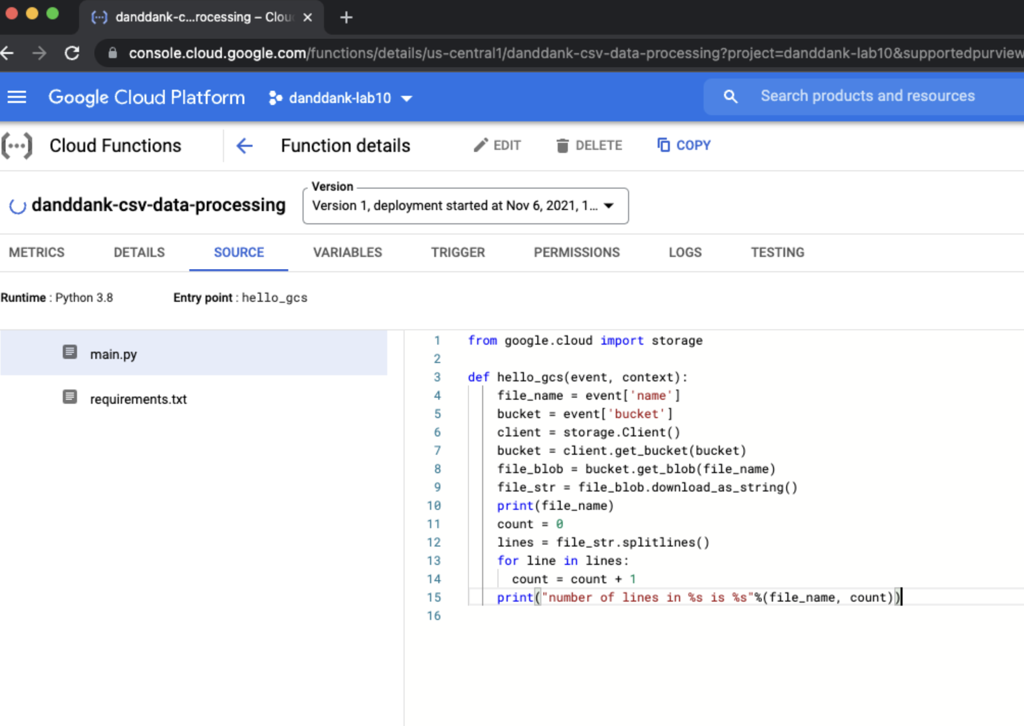

**Lab report screen-shot #20:**

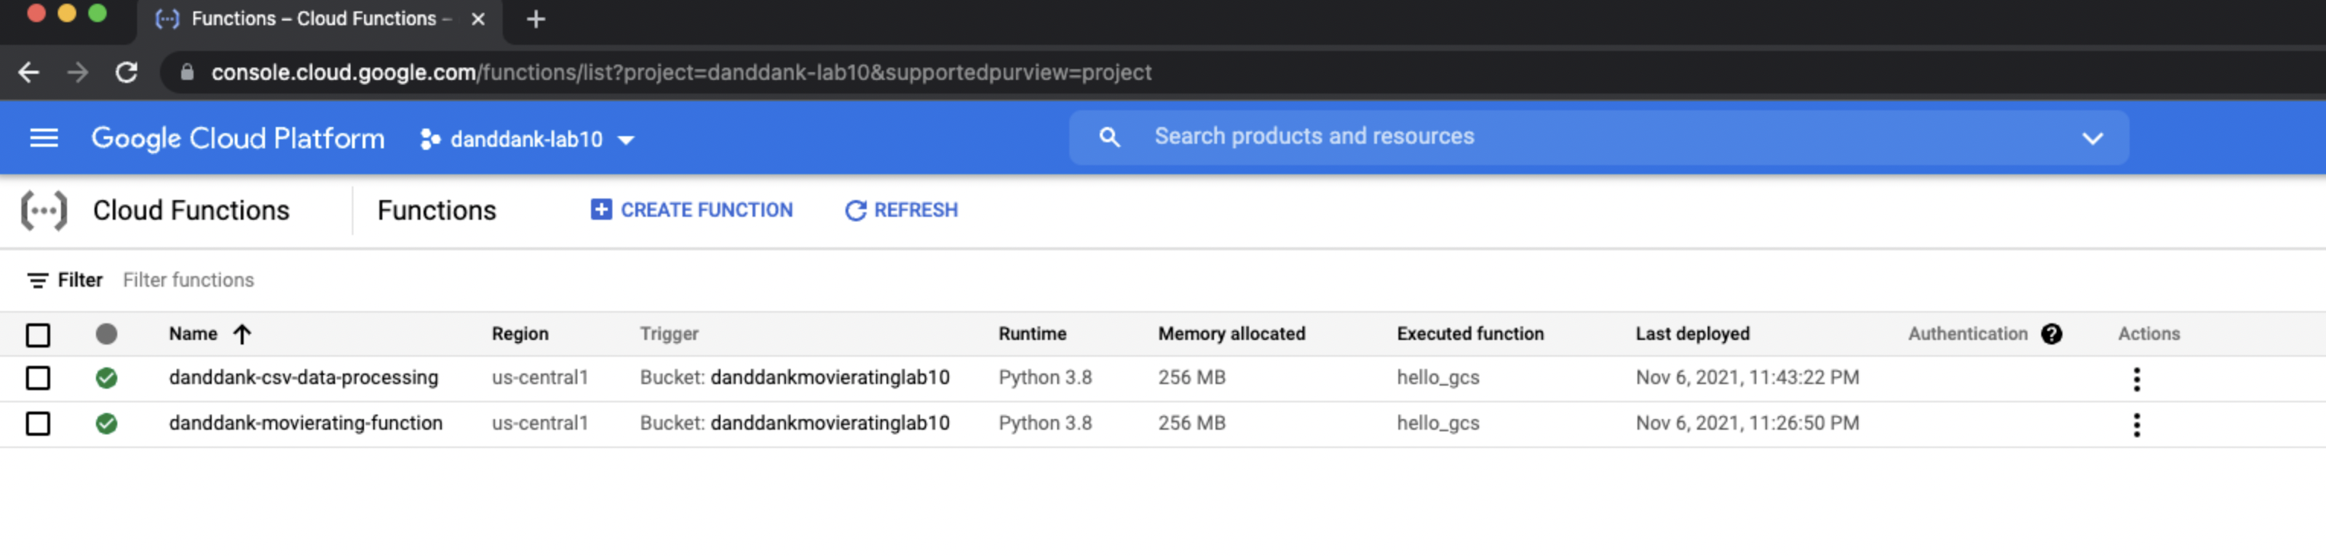

**Lab report screen-shot #21:**

